LAB Assignment No 2
Topic: Multiple and Logistic Linear Regression

Lab Practice Questions
Q1. Multiple Linear Regression – House Price Prediction
A dataset contains:
- Size (sqft),
- Number of Bedrooms,
- Age of House (years)
and the target variable is House Price.
👉 Task:
- Fit a multiple linear regression model.
- Predict the price of a house with: Size = 2000 sqft, Bedrooms = 3, Age = 10 years.
- Print coefficients and interpret them.
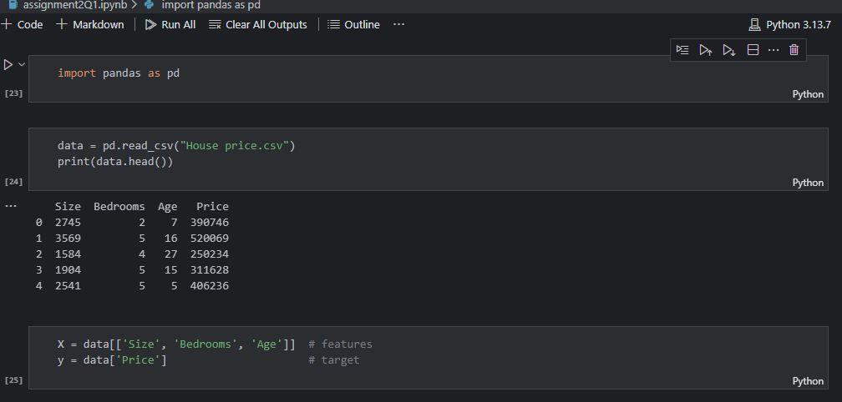
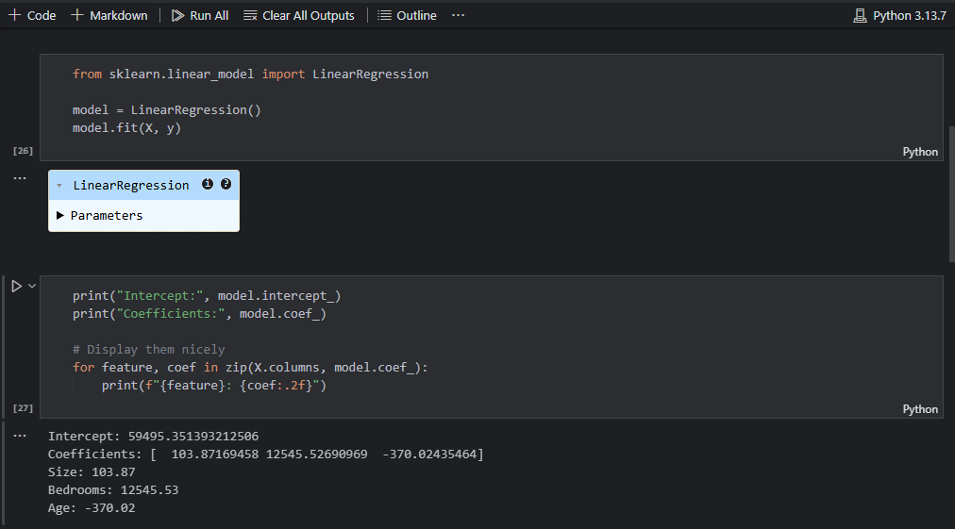
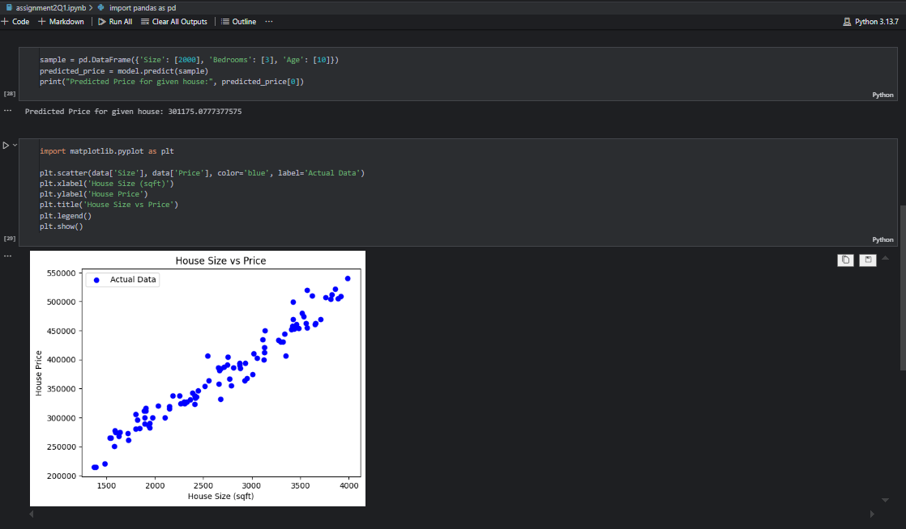
Q2. Multiple Linear Regression – Student Performance
Dataset columns:
- Hours Study,
- Hours Sleep,
- Attendance (%),
Target: Marks in Exam
👉 Task:
- Train a regression model.
- Plot actual vs predicted marks.
- Compute R² score and Mean Squared Error (MSE).
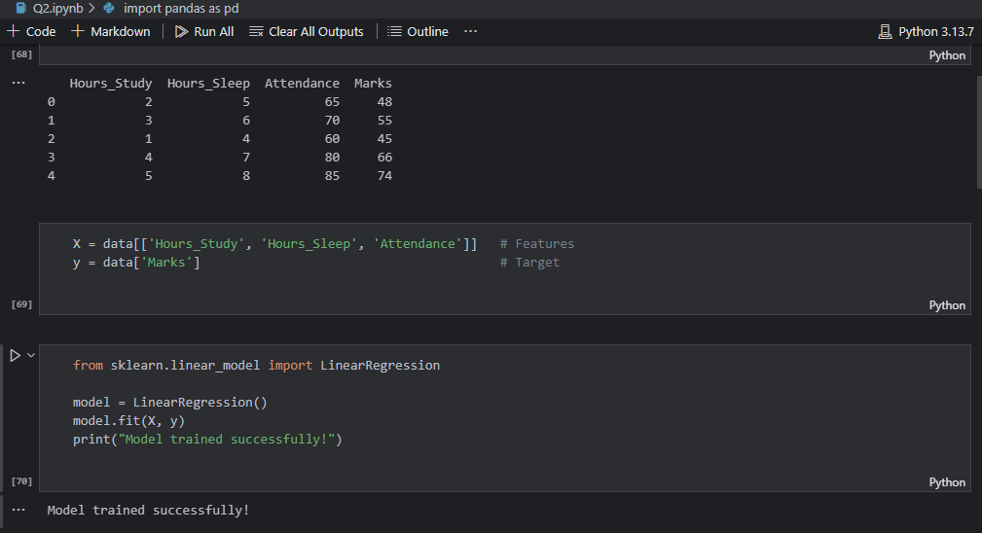
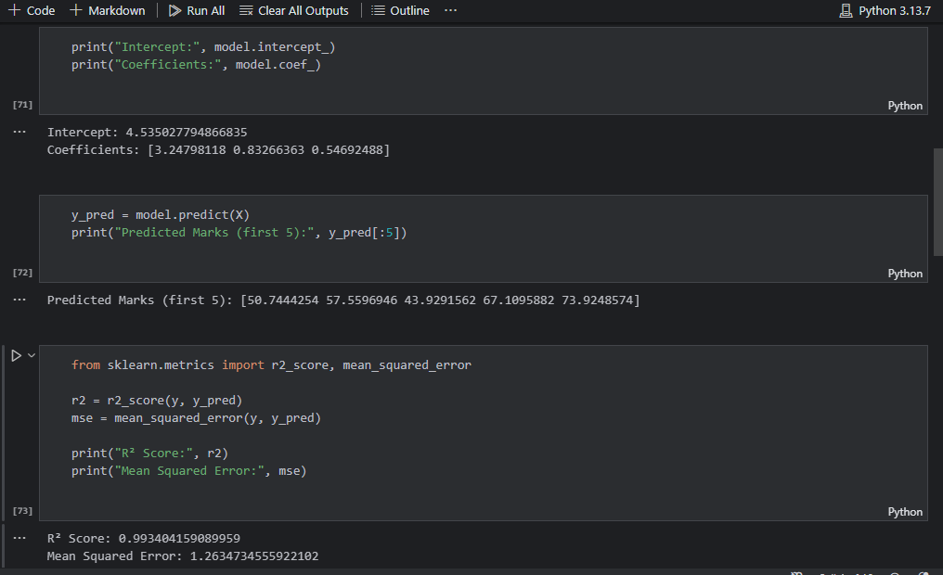
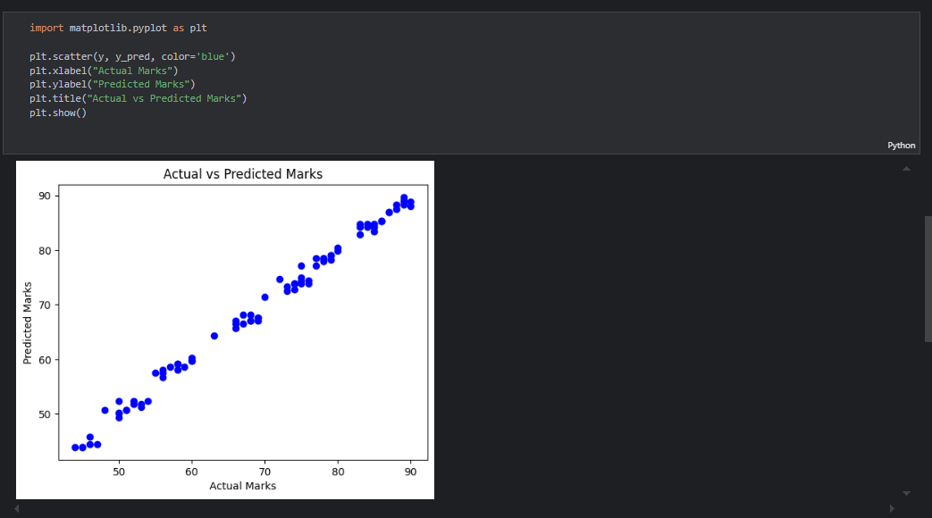
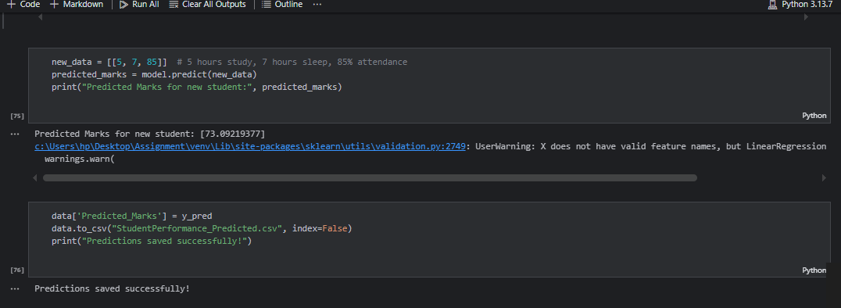

Q3. Logistic Regression – Pass/Fail Classification
Dataset columns:
- Hours Study
- Hours Sleep
Target: Pass (1) / Fail (0)
👉 Task:
- Fit a logistic regression classifier.
- Predict the probability of passing if a student studies 30 hours and sleeps 6 hours.
- Plot the decision boundary (pass vs fail).
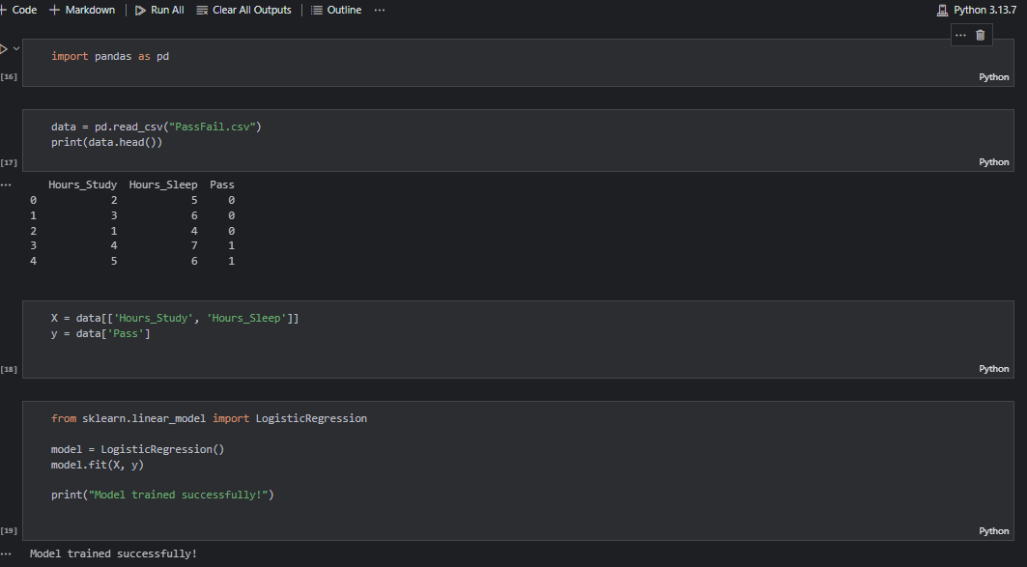
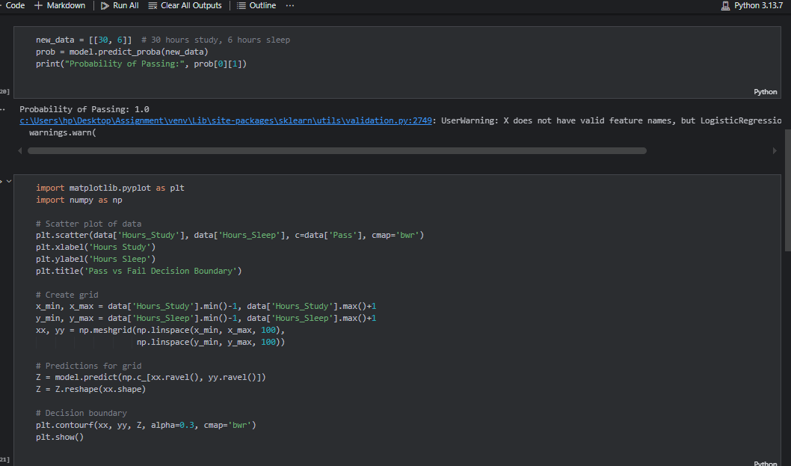
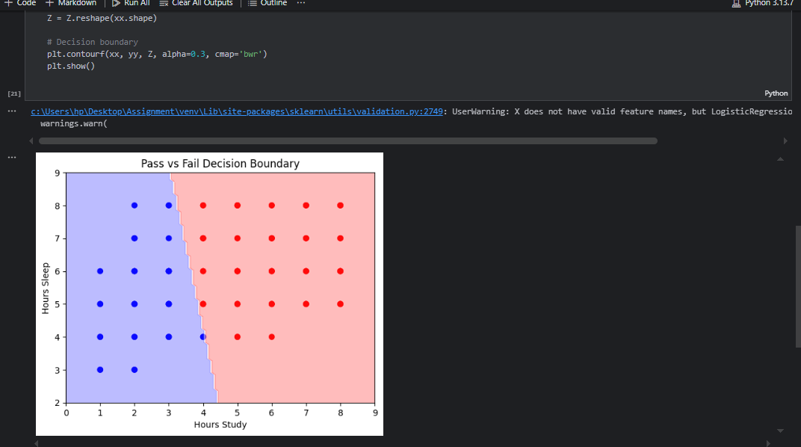
Q4. Logistic Regression – Diabetes Prediction (Binary Classification)
Use a small dataset with:
- BMI,
- Age,
- Glucose Level
Target: Diabetic (1) or Not (0)
👉 Task:
- Fit logistic regression.
- Find accuracy, precision, recall.
- Predict whether a patient (BMI=28, Age=45, Glucose=150) is diabetic.
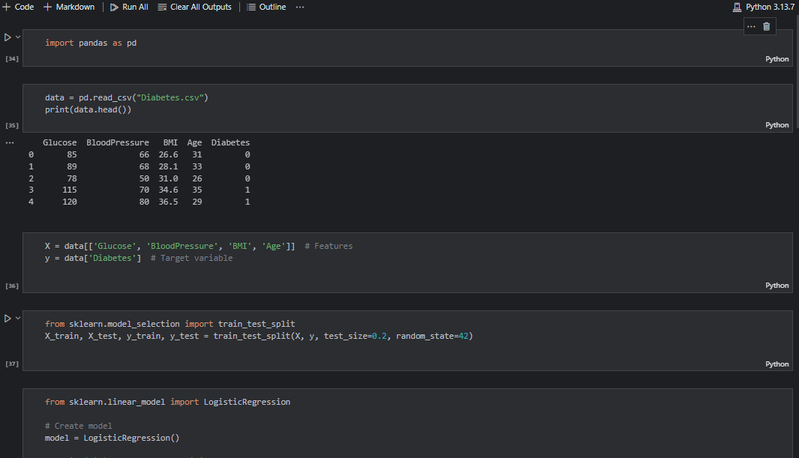
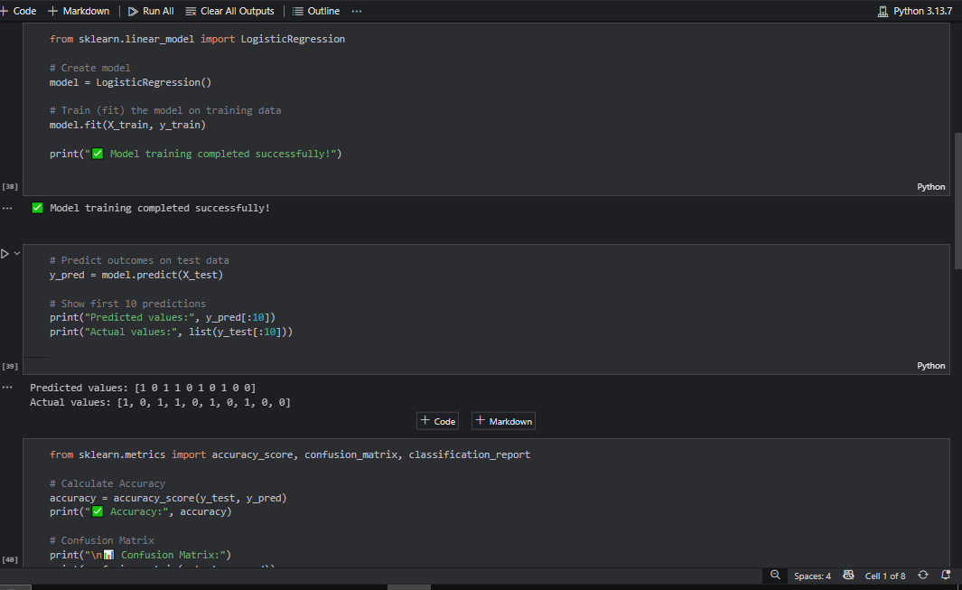
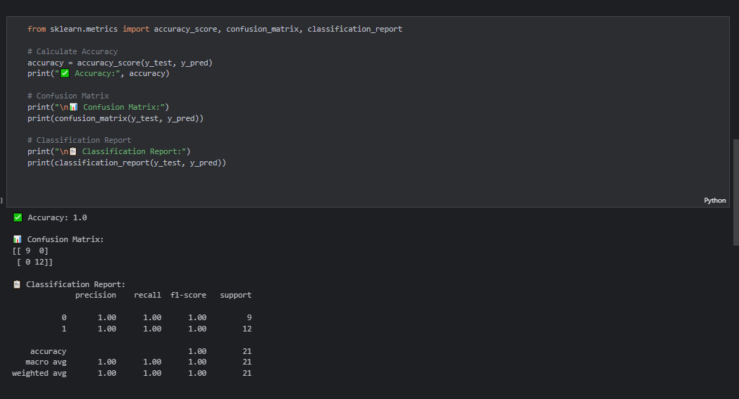
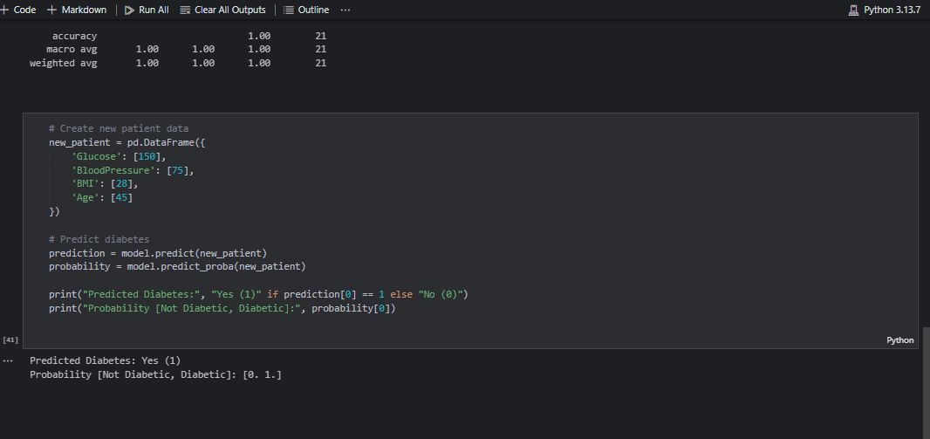
Q5. Comparison – Linear vs Logistic Regression
Dataset columns:
- Hours Study,
- Exam Score,
- Pass/Fail
👉 Task:
- Use Linear Regression to predict exam scores.
- Use Logistic Regression to predict pass/fail.
- Compare results — explain why linear regression is unsuitable for classification.
